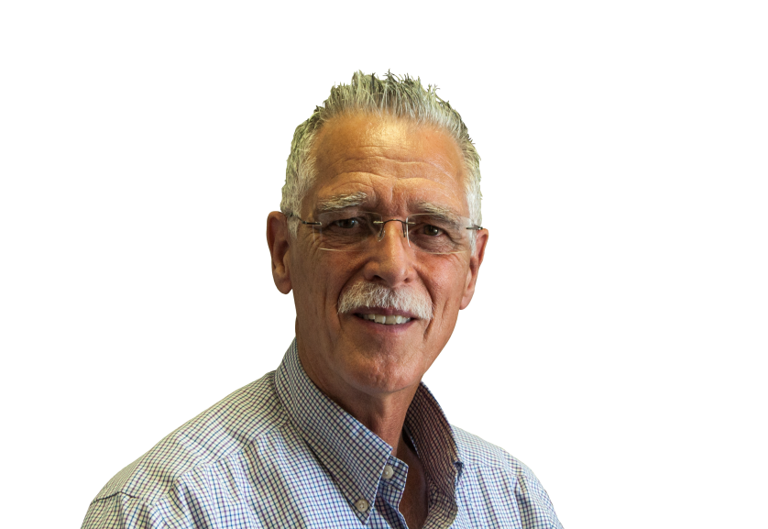
EMDR CONSULTATION GROUP!

Stephen Weathersbee, MA, LMFT

Certified EMDR Therapist Approved Consultant

Steve has been practicing EMDR with a wide variety of populations over the years, including children, adolescents, and adults (couples too). He is an Approved Consultant with EMDRIA, having been trained under DaLene Forester, PhD. His approach focuses on fidelity to the original 8 phase protocol, as taught by Dr. Francine Shapiro. He has witnessed the amazing healing effect of using EMDR in the treatment of PTSD, Anxiety Disorders (including Panic Disorder, OCD, Specific Phobias), addictions, depression, and even psychotic disorders.
A group is now being formed to provide consultation for therapists who have completed the Basic Training course and desire to further develop their skills while accruing consultation hours toward certification. EMDRIA guidelines permit you to do up to 10 consultation hours as part of a group. Consultation will be conducted in two-hour sessions (see below for dates, times), with telephone participation via a toll-free number. The cost for the 5 sessions (10 consultation hours) is $350.00 (full payment required prior to the first session).
Sessions will be conducted:
- January 12, 2015, 5:00-7:00 p.m. , Pacific (6:00-8:00 Mountain; 7:00-9:00 Central; 8:00-10:00 Eastern)
- February 9,2015, 5:00-7:00 p.m. , Pacific (6:00-8:00 Mountain; 7:00-9:00 Central; 8:00-10:00 Eastern)
- March 9, 2015, 5:00-7:00 p.m. , Pacific (6:00-8:00 Mountain; 7:00-9:00 Central; 8:00-10:00 Eastern)
- April 13, 2015, 5:00-7:00 p.m. , Pacific (6:00-8:00 Mountain; 7:00-9:00 Central; 8:00-10:00 Eastern)
- May 11, 2015, 5:00-7:00 p.m. , Pacific (6:00-8:00 Mountain; 7:00-9:00 Central; 8:00-10:00 Eastern)
Phone: (530) 722-5212 Fax: (530) 243-4200
www.steveweathersbee.com swbeelmft@hotmail.com

